**SQL – Skill Up By GeeksForGeeks**

# **Components of a Database**

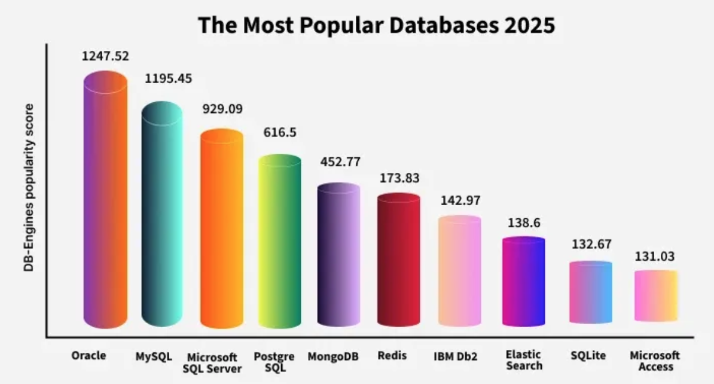

**Data:** Actual information like text, numbers, images, or files.

**Schema:** Structural blueprint - tables, fields, data types, and relationships.

**DBMS:** Database management software → storage, retrieval, security (e.g., MySQL, Oracle)

**Queries:** Instructions to retrieve or manipulate data

**Users:** People/systems with specific roles and access rights

# **Types of Databases**

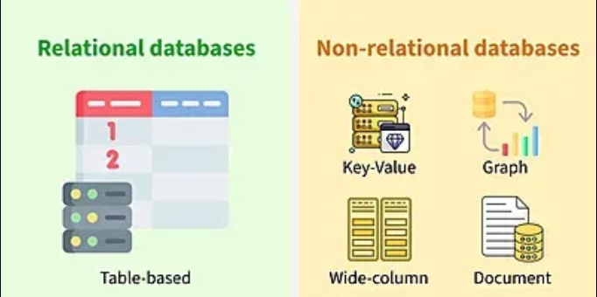

1. **Relational Databases (RDBMS)**

Organize data into tables made up of rows (records) and columns (fields)

Strict schema-based structure.  
Primary Keys and Foreign Keys   
Strong ACID compliance (Atomicity, Consistency, Isolation, Durability).  
Ideal for structured data.

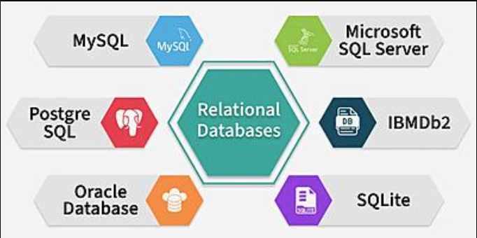

1. **NoSQL Databases**

Handle unstructured/semi-structured data, like text, images, videos or sensor data

Flexible data models (no fixed schema).  
Scales horizontally for high-volume data.  
Often optimized for specific use cases like graphs or time-series data.

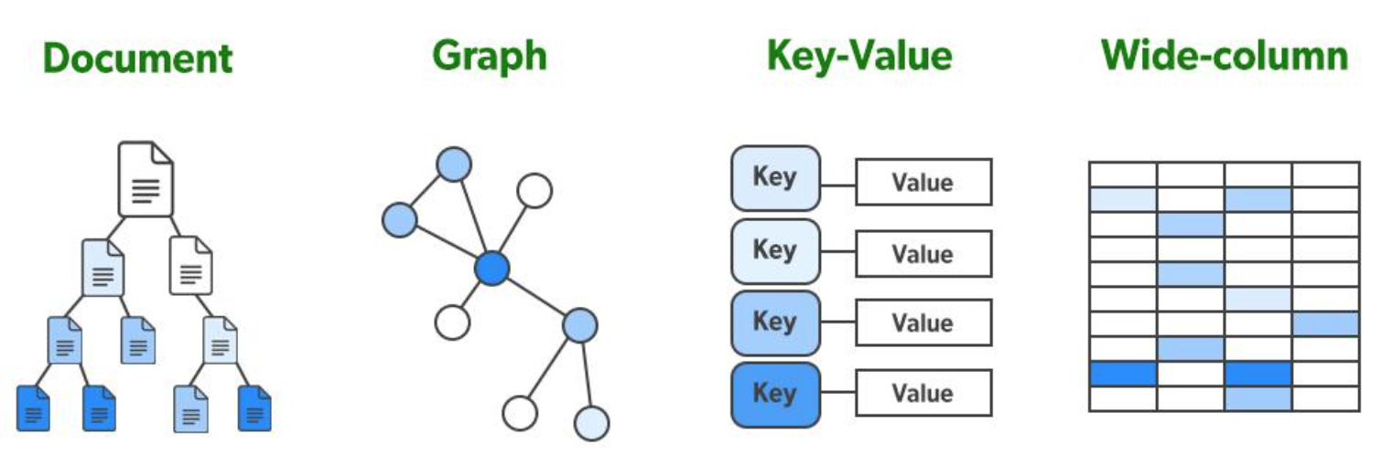

* Document Databases – Store data as JSON-like documents. (Example: MongoDB)
* Key-Value Stores – Store simple key–value pairs for fast lookups. (Example: Redis)
* Columnar Databases – Store data by columns for analytics. (Example: Apache Cassandra)
* Graph Databases – Store nodes & relationships for connected data. (Example: Neo4j)

# **ACID Properties**

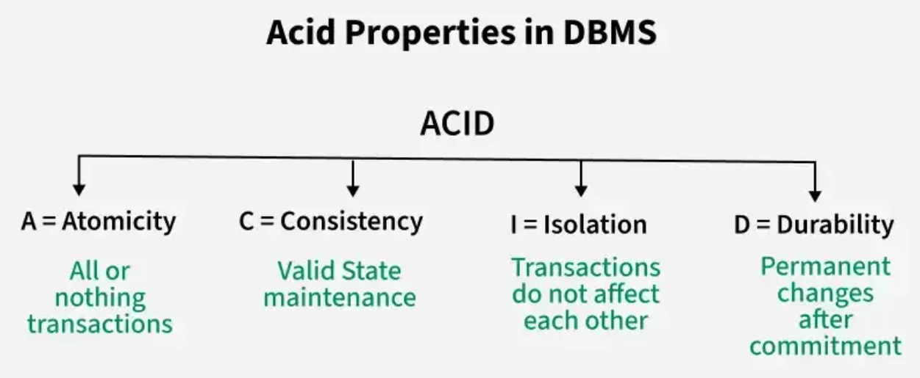

# **Types Of DBMS Language**

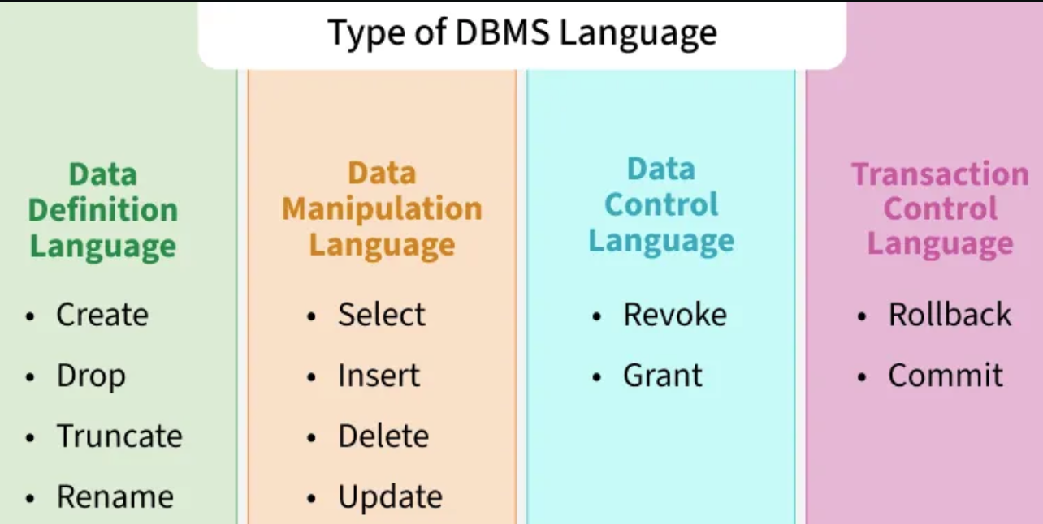

## **Data Definition Language**

* **Create Table Create table from existing table**

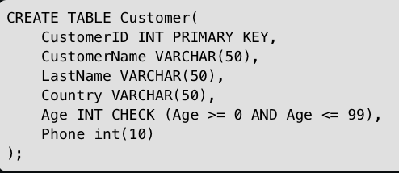 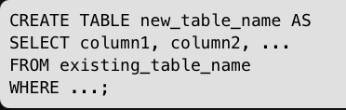

* **Drop Table/Database**

DROP TABLE table_name;   
DROP DATABASE database_name;

* **Truncate Table**

TRUNCATE TABLE table_name;

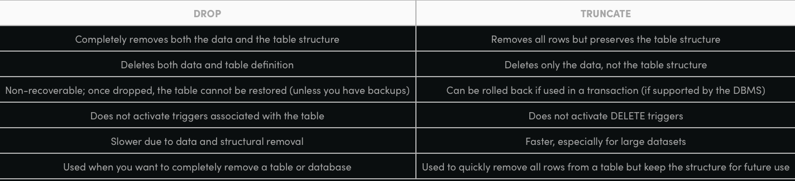

* **Alter Table**

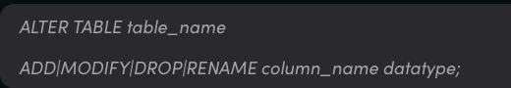

* **Rename = change the name**

ALTER TABLE old_table_name RENAME TO new_table_name;

ALTER TABLE table_name RENAME COLUMN old_column_name TO new_column_name;

ALTER TABLE table_name RENAME INDEX old_index TO new_index;

* **Modify = change the structure/definition**

ALTER TABLE employees MODIFY first_name VARCHAR(100);  
ALTER TABLE table_name MODIFY column_name data_type NOT NULL;  
ALTER TABLE table_name MODIFY column_name data_type DEFAULT 'value';

* **Drop**

ALTER TABLE table_name DROP COLUMN column_name;

ALTER TABLE table_name DROP CONSTRAINT constraint_name;

ALTER TABLE table_name DROP PRIMARY KEY;

ALTER TABLE table_name DROP FOREIGN KEY fk_name;

ALTER TABLE table_name DROP INDEX index_name;

* **Add = insert a new column or constraint into the table.**

ALTER TABLE table_name ADD column_name data_type;

ALTER TABLE table_name

ADD (

column1 data_type,

column2 data_type

);

ALTER TABLE table_name ADD CONSTRAINT pk_name PRIMARY KEY (column_name);

ALTER TABLE table_name ADD CONSTRAINT fk_name FOREIGN KEY (column_name) REFERENCES other_table(other_column);

ALTER TABLE table_name ADD CONSTRAINT unique_name UNIQUE (column_name);

ALTER TABLE table_name ADD CONSTRAINT chk_name CHECK (condition);



## **Data Manipulation Language**

* **Select Data**

Select * from table_name where some_condition;

* **Insert Data**

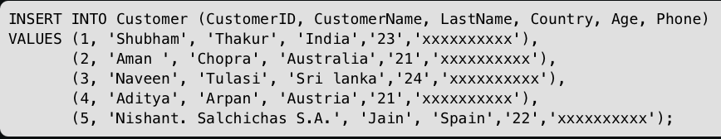

* **Update Data**

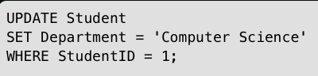

* **Delete Data**

DELETE FROM table_name WHERE some_condition;

* **Common Constraint**

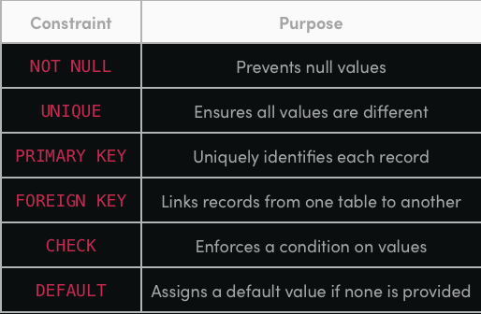

## **Data Control Language**

* **Revoke**

GRANT privilege_list ON object_name TO user_name;  
Eg. GRANT SELECT, INSERT ON employees TO user1;

* **Grant**

REVOKE privilege_list ON object_name FROM user_name;  
eg. REVOKE SELECT ON employees FROM user1;

## **Transaction Control Language**

* **BEGIN TRANSACTION Command** - beginning of a new transaction

BEGIN TRANSACTION transaction_name ;  
  
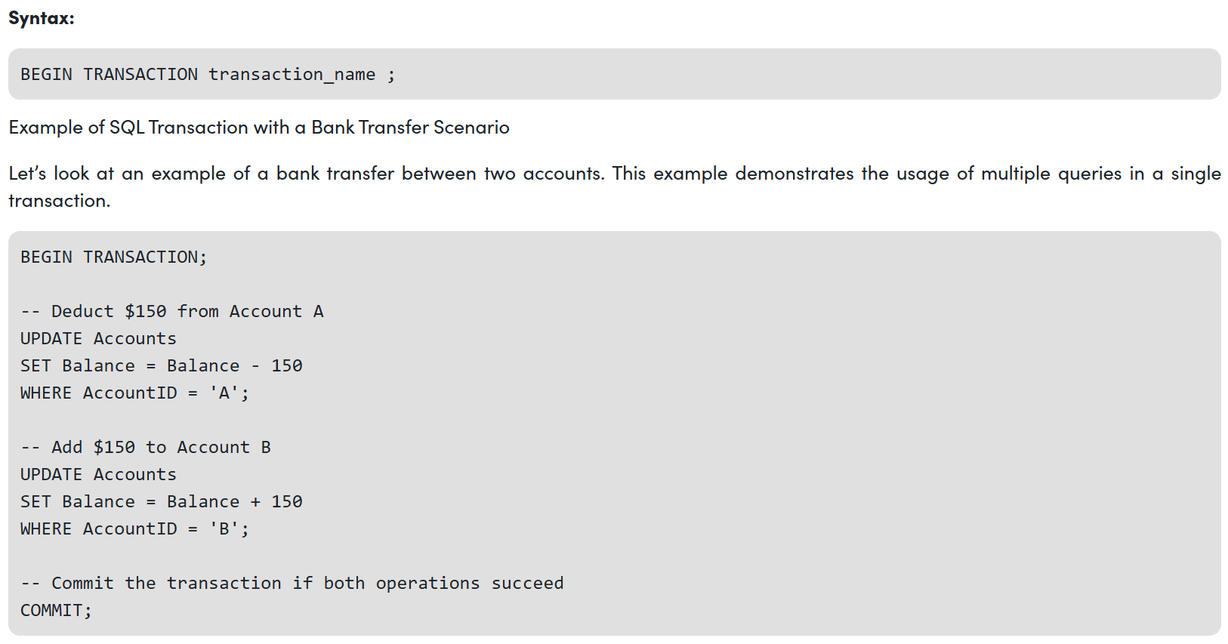

* **COMMIT Command -** save all changes, once a transaction is committed, the changes are permanent.

Eg. DELETE FROM Student WHERE AGE = 20;

COMMIT;

* **ROLLBACK Command -** undo all changes made in the current transaction

Eg. DELETE FROM Student WHERE AGE = 20;

ROLLBACK;

* **SAVEPOINT Command -** Create a checkpoint within a transaction. This allows us to undo part of the transaction rather than the entire transaction

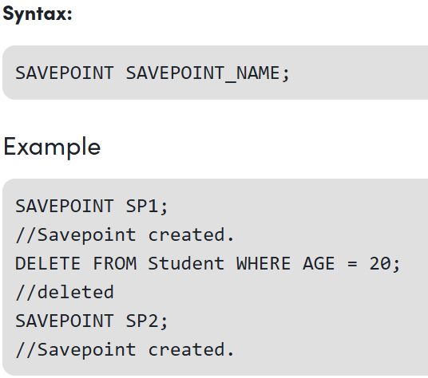

* **ROLLBACK TO SAVEPOINT -** roll back the transaction to a specific savepoint

Syntax: ROLLBACK TO SAVEPOINT SAVEPOINT_NAME;

* **RELEASE SAVEPOINT Command -** remove a SAVEPOINT that was created

Syntax: RELEASE SAVEPOINT SAVEPOINT_NAME;

# **SQL Joins**

**Types of SQL Joins**

* **INNER JOIN**

Combine rows from two or more tables based on a related column and returns only the rows that have matching values in both tables

Syntax:

SELECT columns FROM table1  
INNER JOIN table2 ON table1.column_name = table2.column_name;

* **LEFT JOIN**

LEFT JOIN (also called LEFT OUTER JOIN) retrieves all records from the left table and only the matching records from the right table. If no match is found in the right table, the query will return NULL values for its columns.

Syntax:

SELECT column_name(s) FROM tableA

LEFT JOIN tableB ON tableA.column_name = tableB.column_name;

* **RIGHT JOIN**

RIGHT JOIN (also called RIGHT OUTER JOIN) is used to combine rows from two tables based on a related column. It returns all records from the right table and only the matching records from the left table. If there is no match in the left table, the result will show NULL values for the left table’s columns.

Syntax:

SELECT column_name(s) FROM tableA   
RIGHT JOIN tableB ON tableA.column_name = tableB.column_name;

* **FULL JOIN**

FULL JOIN (or FULL OUTER JOIN) in SQL returns all rows from both tables, combining matched rows and filling unmatched rows with NULL values. It is basically the combination of LEFT JOIN and RIGHT JOIN

Syntax:

SELECT columns FROM table1  
FULL JOIN table2 ON table1.column = table2.column;

* **SELF JOIN**

Used when a table needs to be joined with itself to compare rows within the same table. It helps in finding relationships between records in a single table by treating it as two separate instances using table aliases.

Syntax:

SELECT columns FROM table AS alias1  
JOIN table AS alias2 ON alias1.column = alias2.related_column;

* **CROSS JOIN**

Creates a Cartesian product of two tables, meaning it returns every possible combination of rows from both tables. It does not use a join condition, and the total number of rows in the result is the number of rows in the first table multiplied by the number of rows in the second table. It is useful for generating all combinations of data.

Syntax:

SELECT * FROM table1  
CROSS JOIN table2;

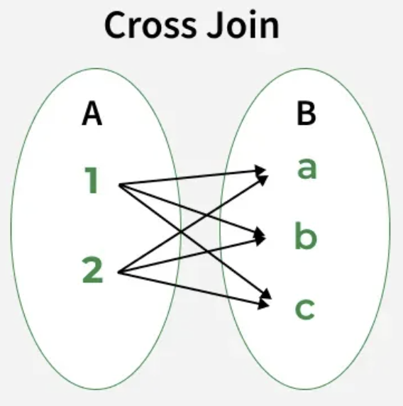

* **MULTIPLE JOINS**

Allow you to combine data from more than one table in a single query. This helps efficiently retrieve complex datasets without running multiple separate queries.

Eg1:

SELECT s.id, s.name, m.marks, a.attendance FROM students AS s

INNER JOIN marks AS m ON s.id = m.id

INNER JOIN attendance AS a ON s.id = a.id

WHERE a.attendance >= 75;

Eg2:

SELECT s.id, s.name, m.marks, a.attendance FROM students AS s

LEFT JOIN marks AS m ON s.id = m.id AND m.marks > 70

LEFT JOIN attendance AS a ON s.id = a.id;

Eg3:

SELECT s.id, s.name, m.marks, a.attendance FROM students AS s

RIGHT JOIN marks AS m ON s.id = m.id AND s.branch='CSE'

RIGHT JOIN attendance AS a ON s.id = a.id;

Eg4:

SELECT s.id, s.name, m.marks, a.attendance FROM students AS s

FULL OUTER JOIN marks AS m ON s.id = m.id AND m.marks > 80

FULL OUTER JOIN attendance AS a ON s.id = a.id AND a.attendance >= 80;

# **SQL Clauses**

SQL clauses are the core components of SQL queries that define how data is retrieved, filtered, grouped, and organized from a database.

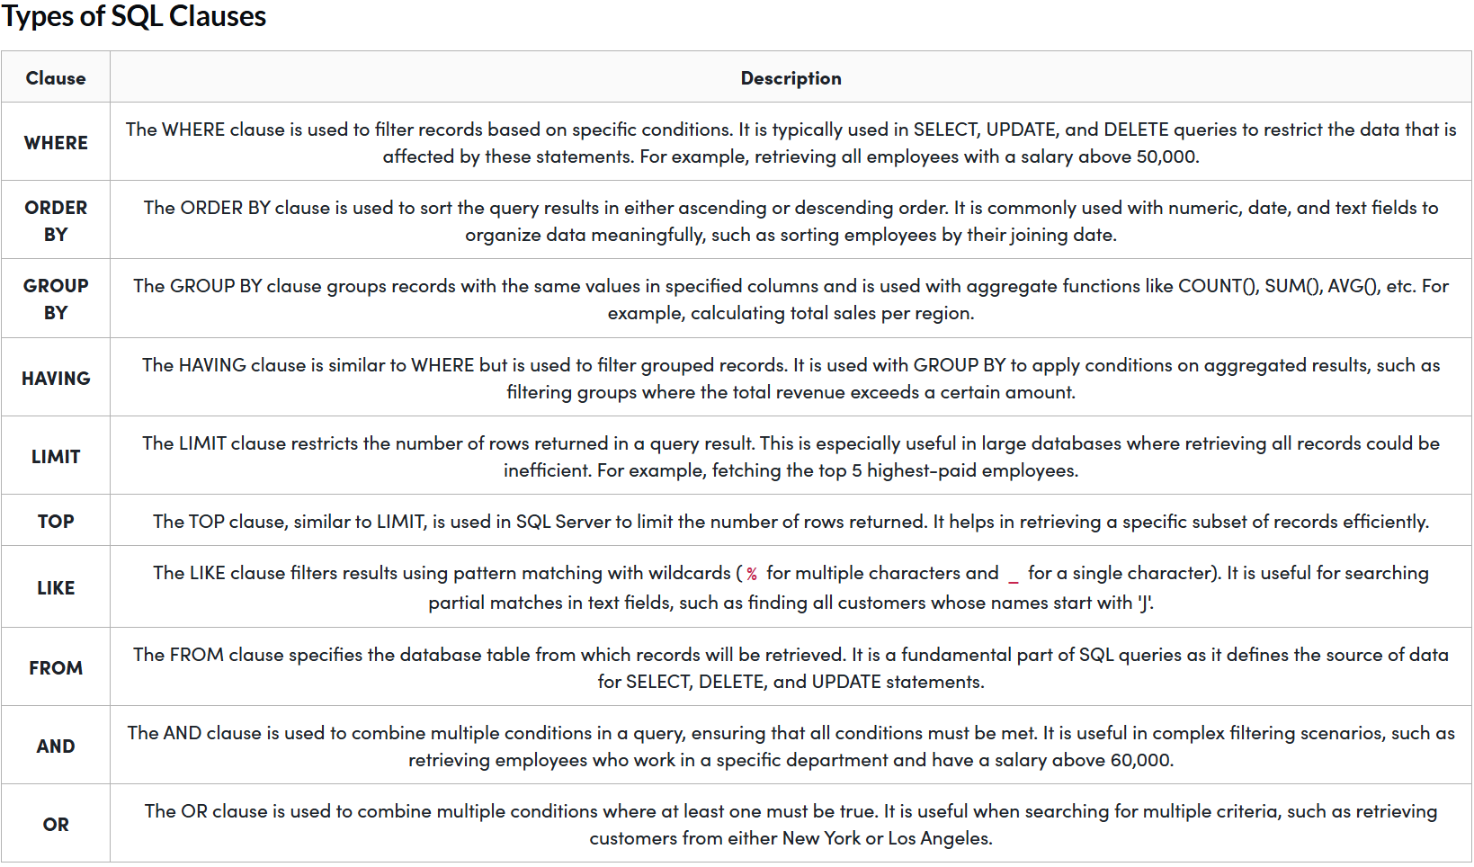

# **SET Operation**

* **UNION**

Combines the results of two or more SELECT queries into one result set. It removes duplicate rows, ensuring the final output contains only unique records. The operation also implicitly sorts the result set to eliminate duplicates.

Syntax:

SELECT column1, column2, column3  
FROM table1  
UNION  
SELECT column1, column2, column3  
FROM table2;

* **UNION ALL**

Combine the set of one or more select statements as the result. The difference between UNION and UNION ALL is that in the UNION ALLoperator there are duplicates in the result sets of SELECT statements whereas in the UNION operator, there areno duplicate values. The UNION ALL is fasterthan the UNION statement because in UNION ALL there is no additional step of eliminating duplicates.

Syntax:  
SELECT column1, column2, column3  
FROM table1  
UNION ALL  
SELECT column1, column2, column3  
FROM table2;

* **Difference Between UNION and UNION ALL**

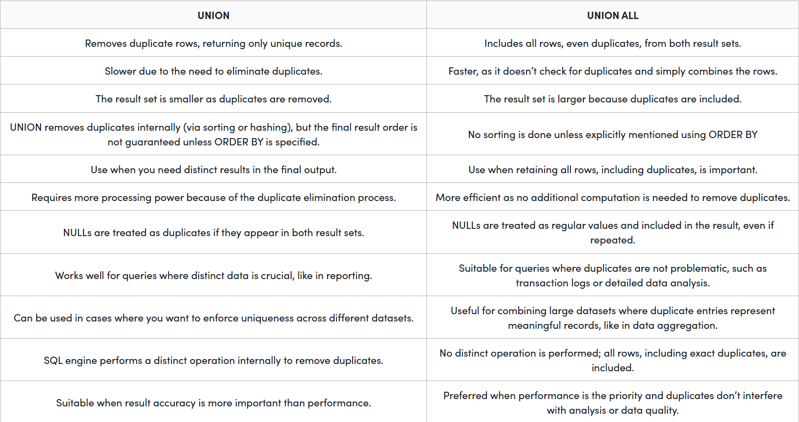

* **INTERSECT**

Returns only the rows that are common to two SELECT queries. It combines results from both queries and keeps only the matching rows.

Syntax:  
SELECT column-1, column-2 ……   
FROM table 1  
WHERE…..  
INTERSECT  
SELECT column-1, column-2 ……   
FROM table 2  
WHERE…..

* **EXCEPT**

Returns rows that are in the first SELECT query but not in the second. It is used to find data present in one set and missing in another.

Syntax:

SELECT column-1, column-2 ……   
FROM table 1  
WHERE…..  
EXCEPT  
SELECT column-1, column-2 ……   
FROM table 2  
WHERE…..

* **MINUS**

Used with two SELECT statements to return only those rows from the first query that are not present in the second. It filters out all common rows and keeps only the unique rows from the first result set

Syntax:

SELECT column1, column2, ..., columnN  
FROM table_name1  
[WHERE condition]  
MINUS  
SELECT column1, column2, ..., columnN  
FROM table_name2  
[WHERE condition];

# **Keys and Constraints**

1. **Not Null**

* NOT NULL is used to enforce mandatory fields.
* It prevents NULL values from being inserted or updated.
* It is applicable at the column level.
* It can be used during table creation or modification (with the ALTER command).

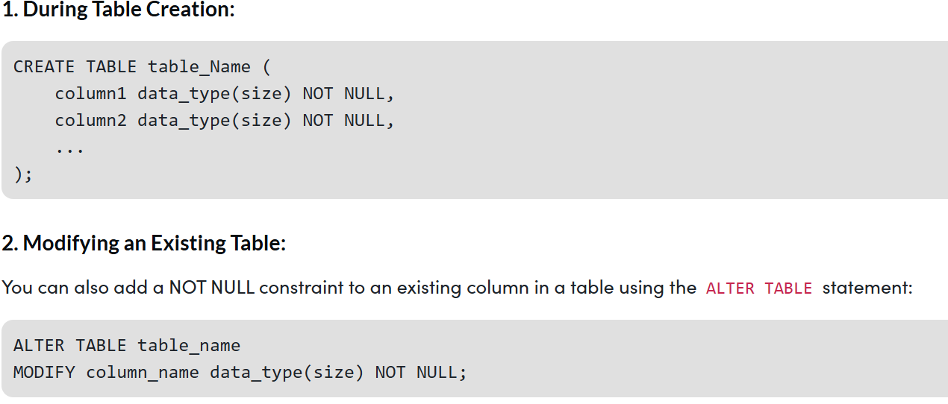

1. **Default**

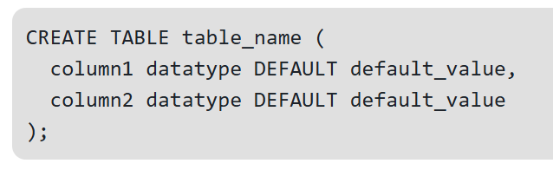

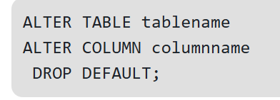

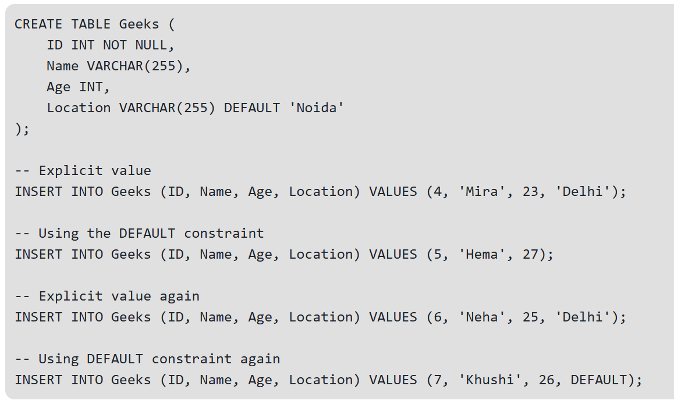

1. **Check**

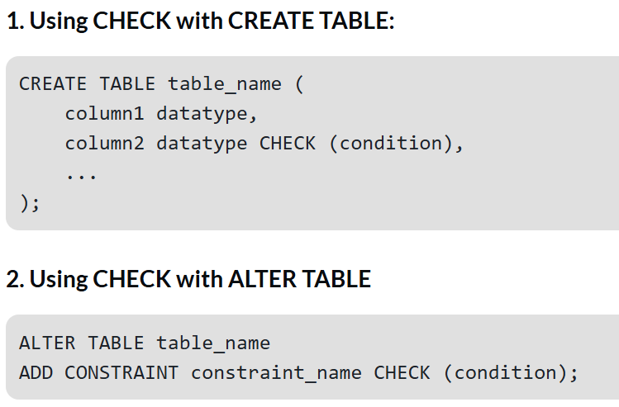

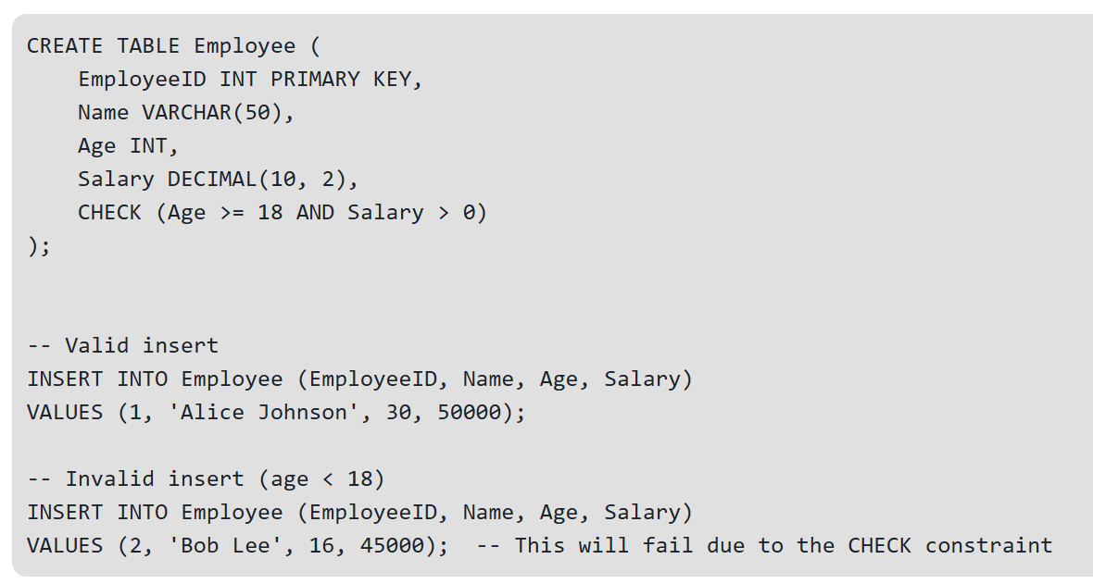

1. **Unique**

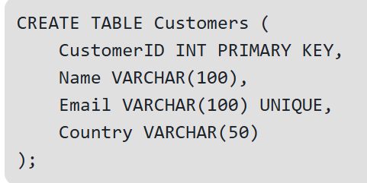

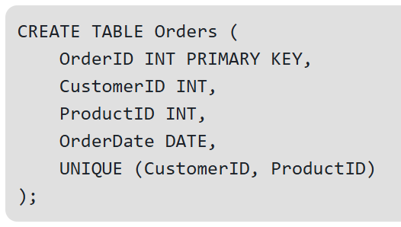

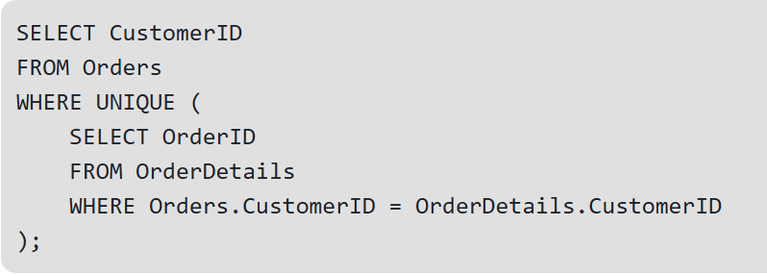

1. **Primary Keys**

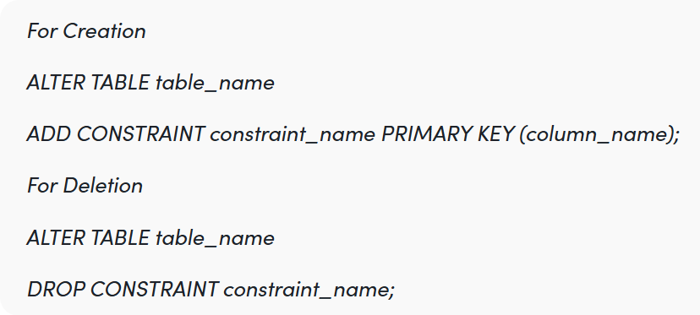

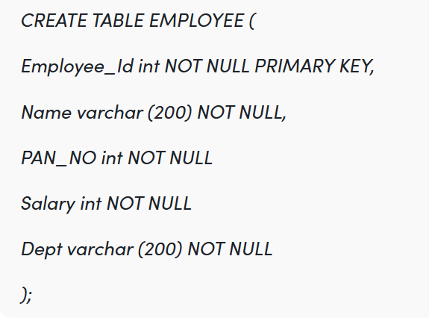

1. **Foreign Keys**

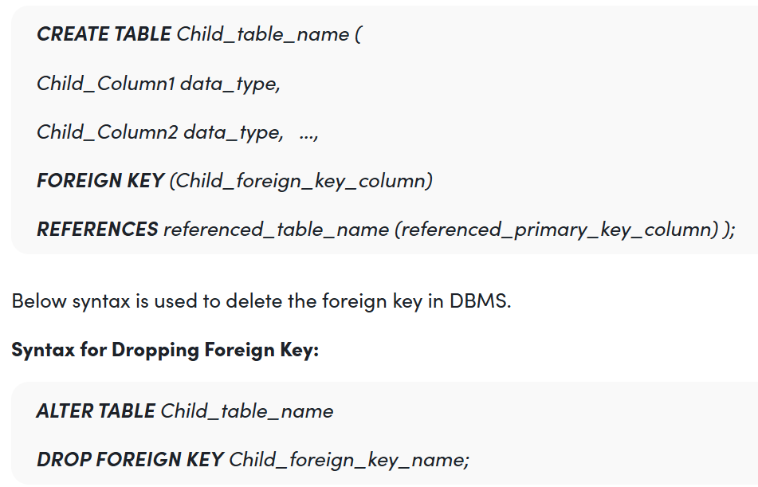

# **SQL Views**

A virtual table created from the result of a SELECT query. It does not store data physically but displays data stored in underlying tables.

1. **Create View Syntax**

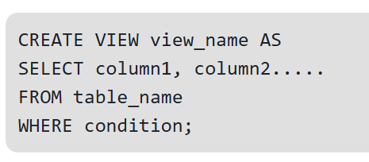

1. **Creating a Simple View from a Single Table**

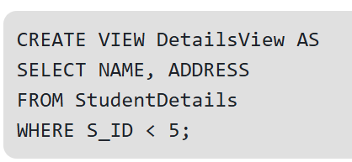

1. **Creating a View from Multiple Tables**

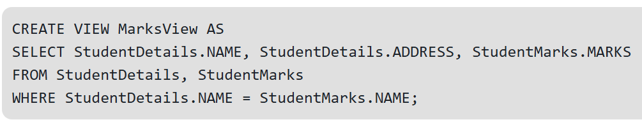

1. **Listing all Views in a Database**

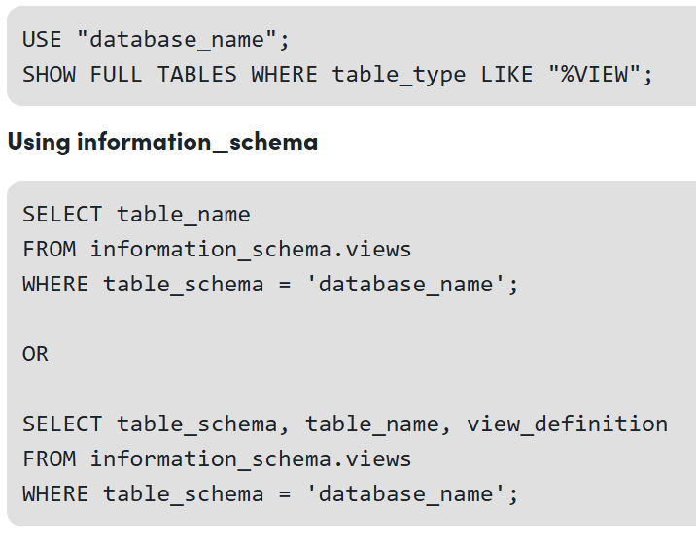

1. **Deleting a View**

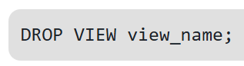

1. **Update the existing data within the view**

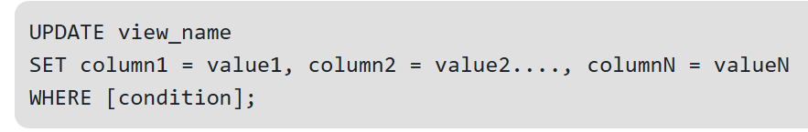

1. **Updating a View Definition**

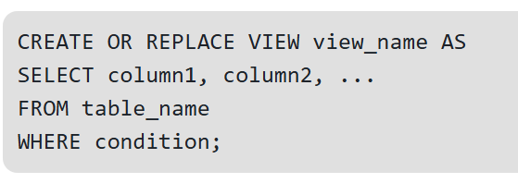

1. **WITH CHECK OPTION Clause**

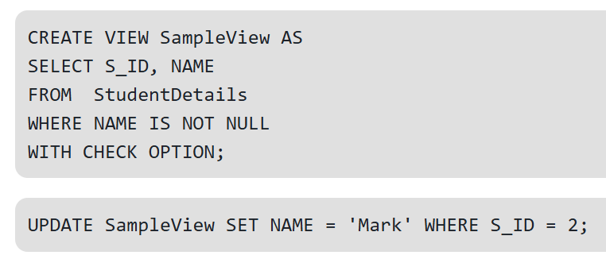

# **Stored Procedure**

**Step 1:**Creating Database

CREATE DATABASE GFG;

**Step 2:**Using Database

USE GFG;

**Step 3:**Create a table

CREATE TABLE gfgTutorial(  
id integer,  
Name varchar(20)  
);

**Step 4:**Describe the table

sp_help 'dbo.gfgTutorial';

**Step 5:**Insert some data into the table

INSERT INTO [dbo].[gfgTutorial]  
 ([id]  
 ,[Name])  
 VALUES  
 (1, 'Devesh')  
GO  
  
INSERT INTO [dbo].[gfgTutorial]  
 ([id]  
 ,[Name])  
 VALUES  
 (2, 'Geeks')  
GO  
  
INSERT INTO [dbo].[gfgTutorial]  
 ([id]  
 ,[Name])  
 VALUES  
 (3, 'For')  
GO  
  
INSERT INTO [dbo].[gfgTutorial]  
 ([id]  
 ,[Name])  
 VALUES  
 (4, 'Geeks')  
GO  
  
INSERT INTO [dbo].[gfgTutorial]E  
 ([id]  
 ,[Name])  
 VALUES  
 (5, 'GFG')  
GO

**Step 6**: Create a Stored procedure for Select all the rows from a table

CREATE PROCEDURE select_all_data  
AS  
BEGIN  
 SELECT * FROM gfgTutorial;  
END;  
GO

**Step 7:** Execute Stored procedure

EXEC select_all_data;

**Parameterized Stored Procedure**

**Step 1:** Create a parameterized stored procedure to insert data in the table

CREATE PROCEDURE insertData  
 @id INT,  
 @Name VARCHAR(30)  
AS  
BEGIN  
 INSERT INTO gfgTutorial (id, Name)  
 VALUES (@id, @Name);  
END;  
GO

**Step 2:**Execute stored procedure

**Query:**

EXEC insertData @id = 6, @Name = 'Inserted Name';

**Create Stored Procedure without Parameter:**

create procedure sp_get_empno

as

begin

select * from emp where ename='WARD'

end

exec sp_get_empno

**Create a Stored Procedure with Output Parameter :**

 You can use the following stored procedure given below to create the stored procedure with an output parameter.

-- Creating the stored procedure with an OUTPUT parameter  
CREATE PROCEDURE sp_get_empid  
 @empId INT OUTPUT  
AS  
BEGIN  
 SELECT @empId = id   
 FROM emp   
 WHERE ename = 'Sam';  
END;  
GO  
  
-- Declaring a variable to hold the output value  
DECLARE @empId INT;  
  
-- Executing the stored procedure  
EXEC sp_get_empid @empId OUTPUT;  
  
-- Displaying the result  
PRINT @empId;

**Create a** **Stored Procedure with Input Parameter :**

 You can use the following stored procedure given below to create the stored procedure with an Input parameter.

USE Db1

GO

CREATE PROCEDURE dbo.GetEmployeeID(@Email varchar(30))

AS

SELECT * FROM employeeDetails WHERE email= @Email

GO

**Create a** **Stored Procedure with both input and Output Parameter :**

 You can use the following stored procedure given below to create the stored procedure with both an input and output parameter.

-- Creating a stored procedure with input and output parameters

CREATE PROCEDURE sp_get_empname

@name VARCHAR(10) OUTPUT,

@id INT

AS

BEGIN

SELECT @name = ename

FROM emp

WHERE empno = @id;

END;

GO

-- Declaring a variable to receive the output value

DECLARE @emp_name VARCHAR(10);

-- Executing the procedure

EXEC sp_get_empname @emp_name OUTPUT, 7521;

-- Printing the output value

PRINT @emp_name;

# **SQL Triggers**

# **ER Model**

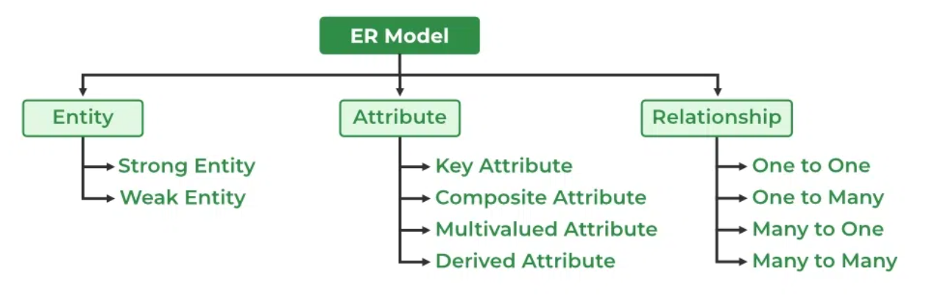

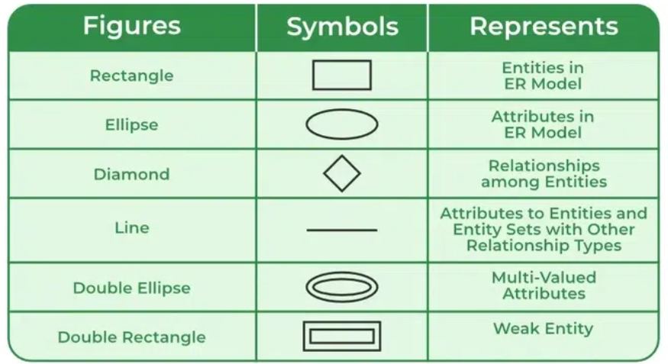

## Entity:

An objects that is stored as data such as *Student*, *Course* or *Company*.

**Entity in DB**

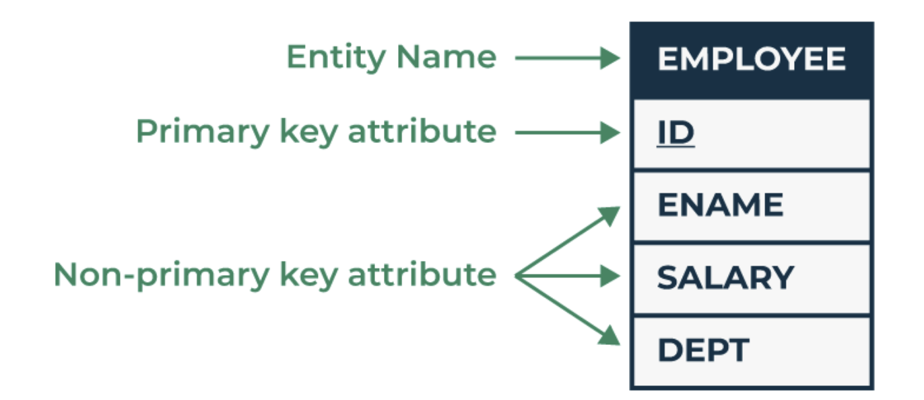

**STRONG ENTITY- entities that exist independently and have a completely unique identifier  
  
WEAK ENTITY - entities depend on another entity and do not have a completely unique identifier on their own**

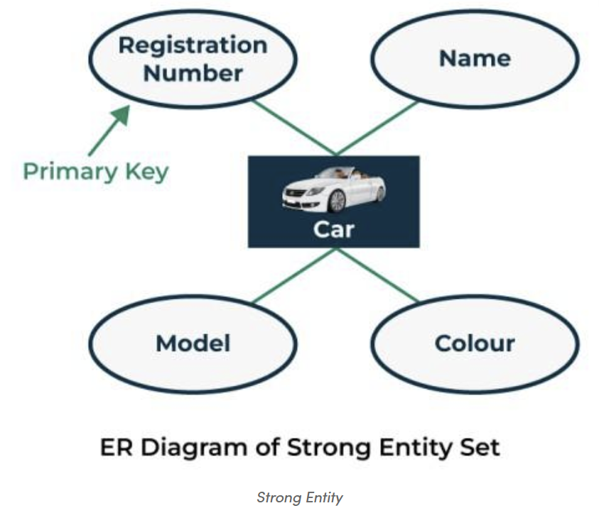 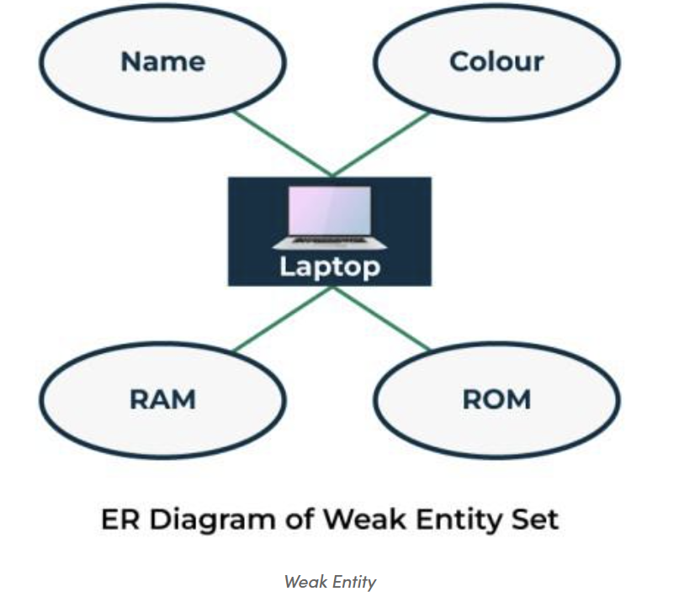

**There are two types of Entities:**

1. Tangible Entity = Physical object or a thing - physically touched, seen or measured (seen directly).  
  
2. Intangible Entity = Abstract/conceptual objects - physically not present but have meaning in db (directly not visible).

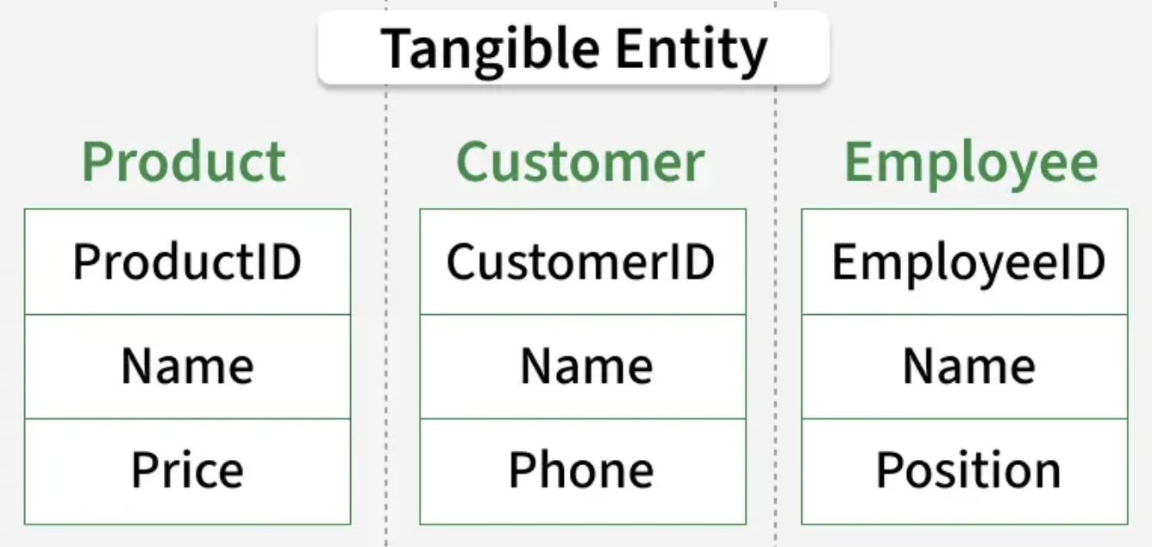 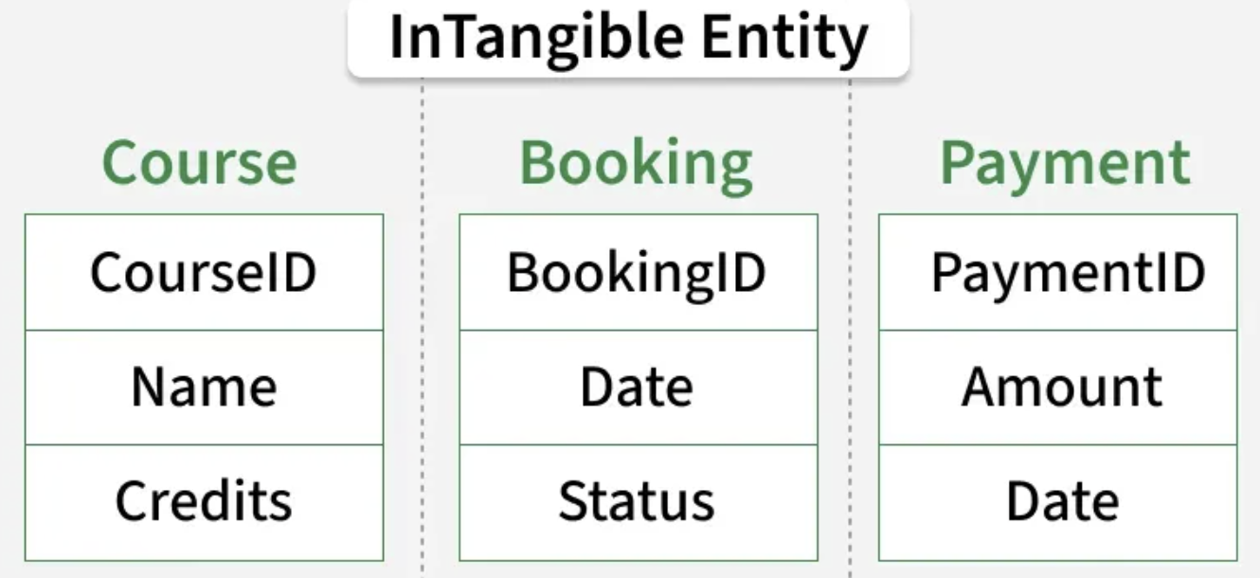

## Attribute

Property or characteristic - describes an entity in a database

**Types of Attribute**

1. Simple Attribute - indivisible properties that hold basic information about an entity, such as name, roll number, or age

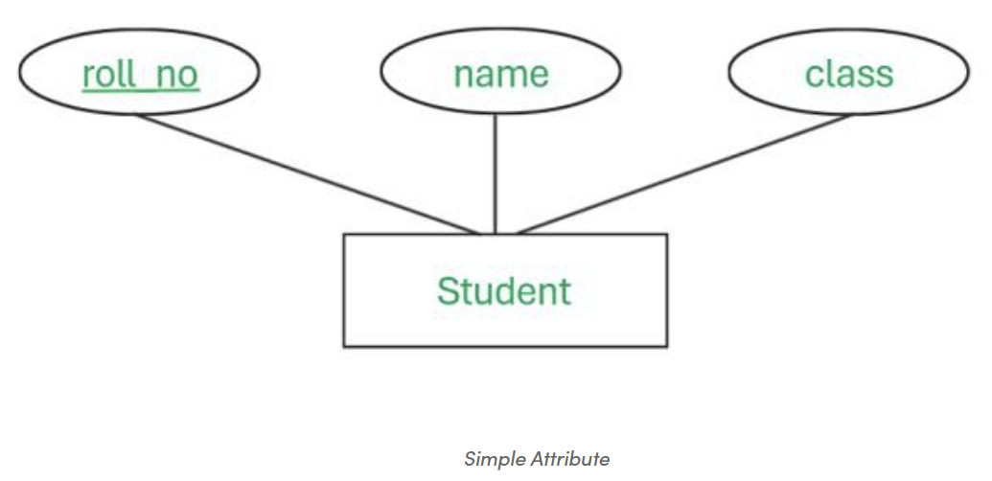

1. Composite Attribute - formed by combining two or more simple attributes. address is the attribute derived from the 3 simple attributes i.e. City, State, and Street.

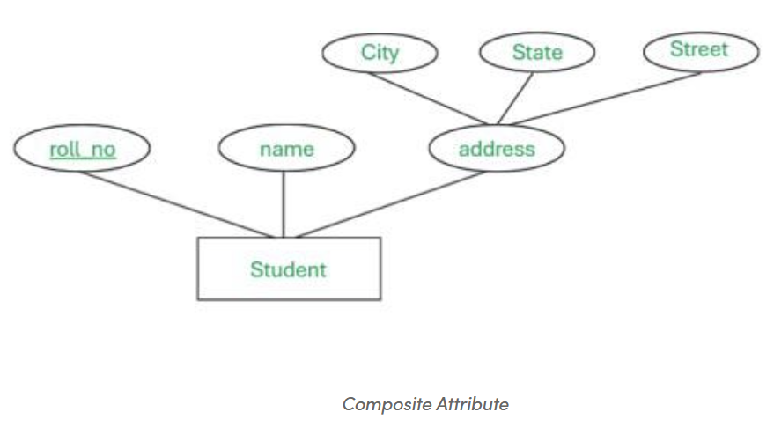

1. Single Valued Attribute - contains only one value per entity instance. DOB attribute will have only one value

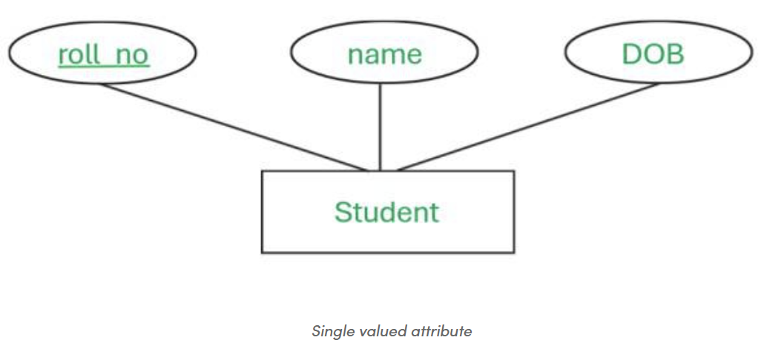

1. Multivalued Attribute - multiple values for one entity instance. One student can have multiple phone_no

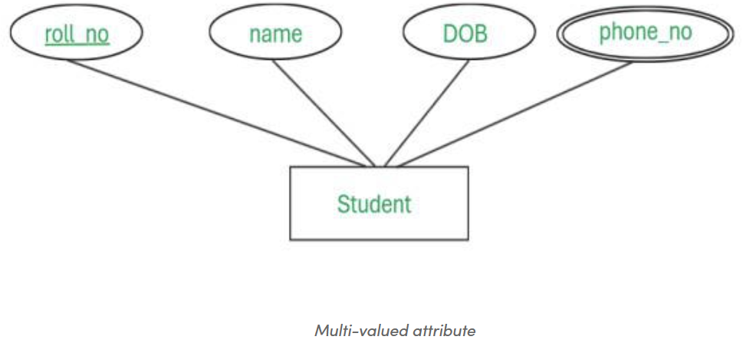

1. Key Attribute - ensure data is distinct in a database. student will have a unique roll_no

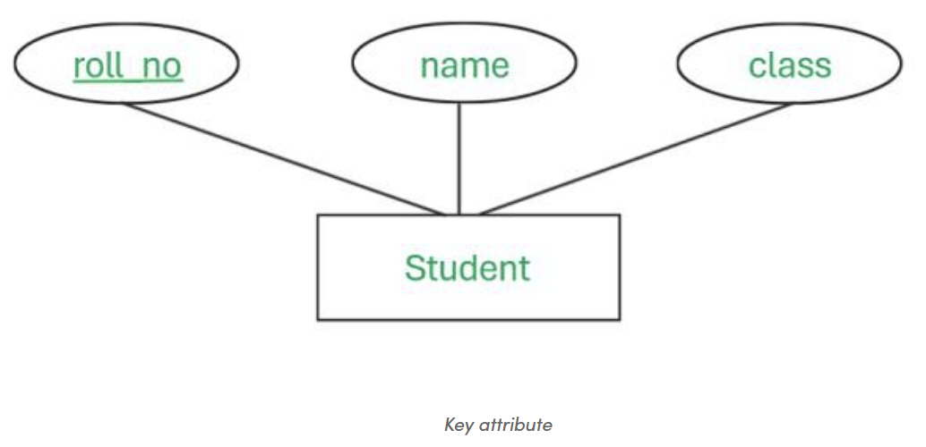

1. Derived Attribute - attribute calculated from other attributes in the database and is not physically stored like age derived from DOB

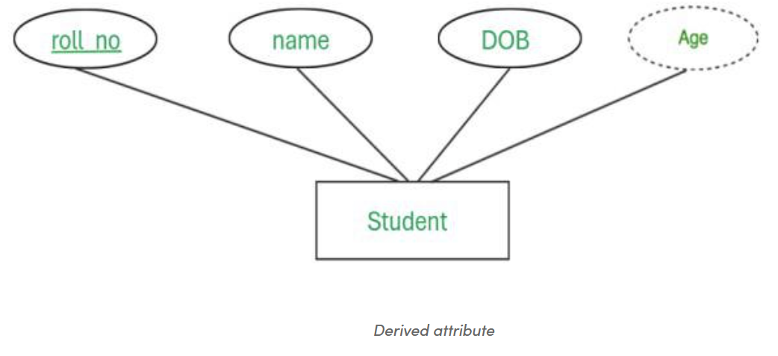

1. Stored Attribute - permanent information that remains fixed throughout the entity’s lifetime like DOB

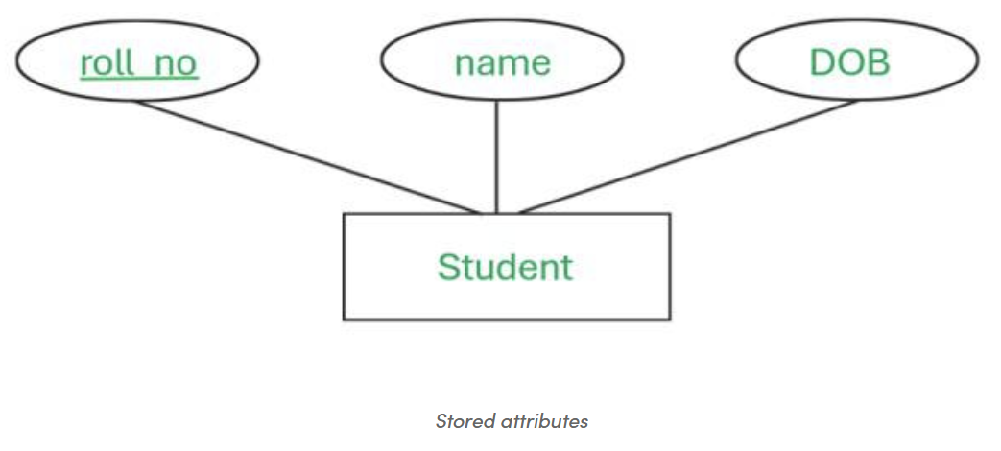

1. Complex Attribute - combination of composite and multivalued attributes. attribute named contact_info which further decomposed into phone_no + Address. The address is a composite attribute which is further divided into simple attributes and phone_no is a multivalued attribute.

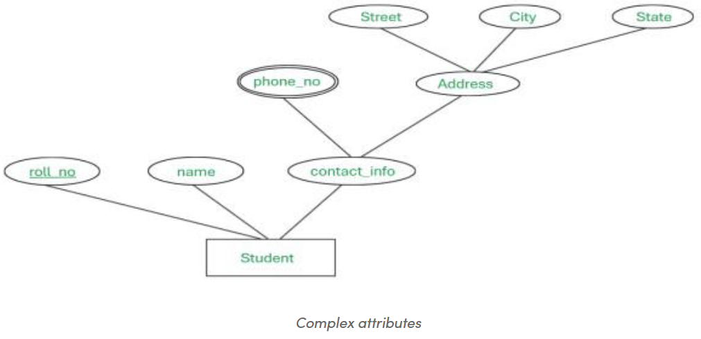

## Relationship

A connection between entities such as "a *Student* enrolls in a *Course*".

1. **One-to-One:** Each record in Table A is associated with one and only one record in Table B, and vice versa.

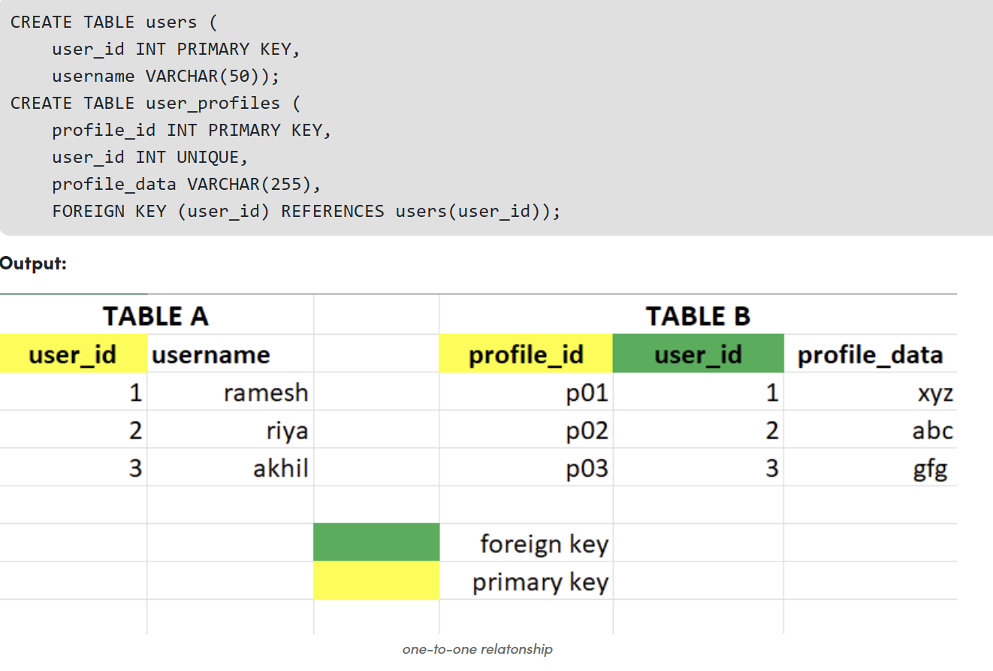

1. **One-to-Many Relationship:** Each record in Table A can be associated with multiple records in Table B, but each record in Table B is associated with only one record in Table A.

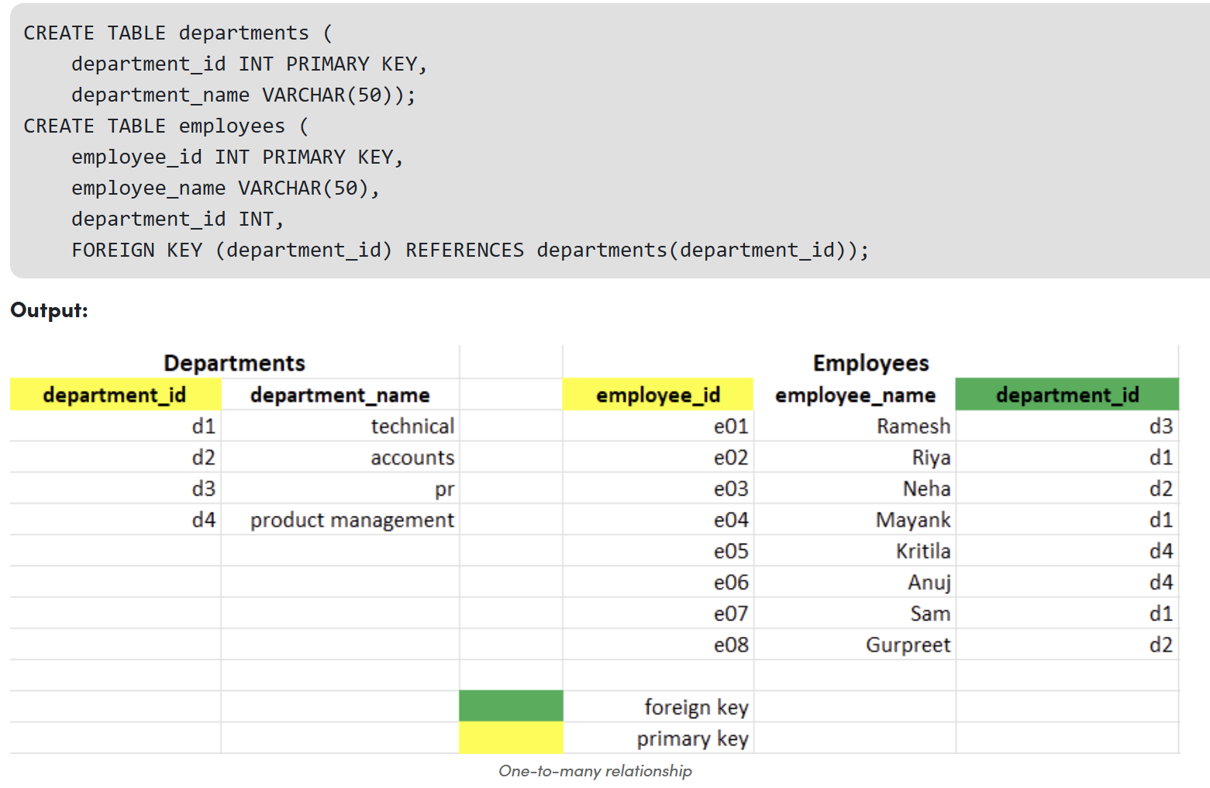

1. **Many-to-Many:** Each record in Table A can be associated with multiple records in Table B, and vice versa.

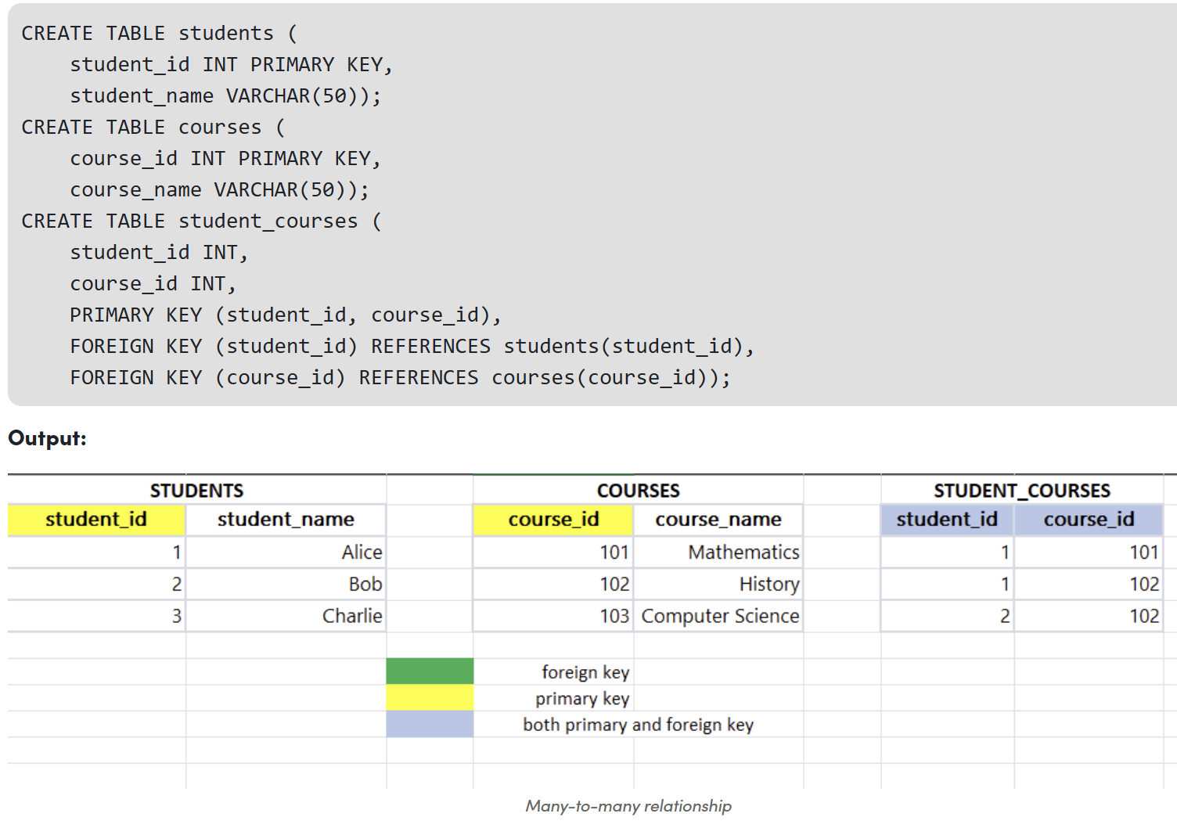

1. **Many-to-One:** Multiple records in table B can be associated with one record in table A.

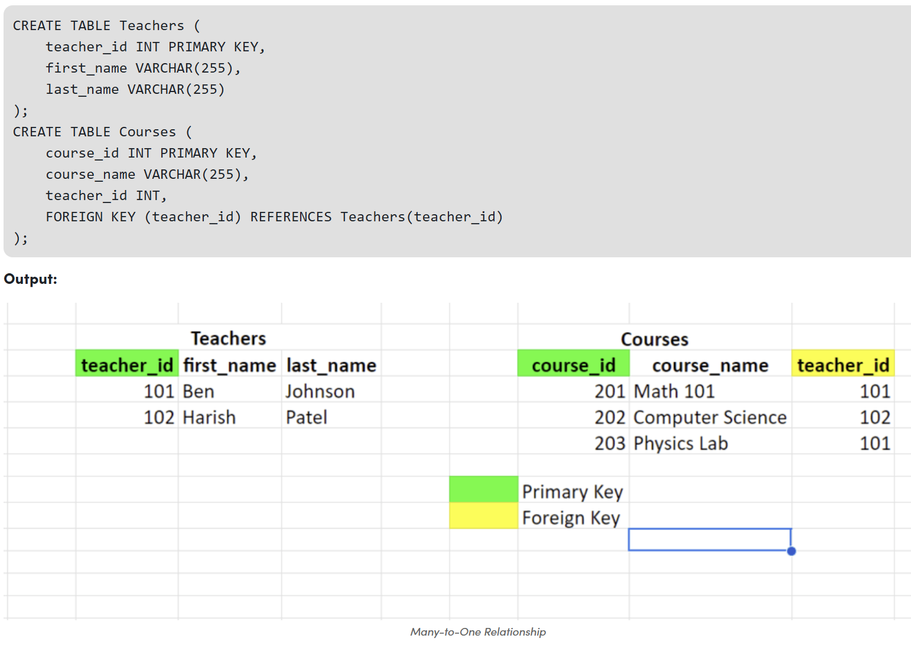

1. **Self-Referencing:** A table has a foreign key that references its primary key.

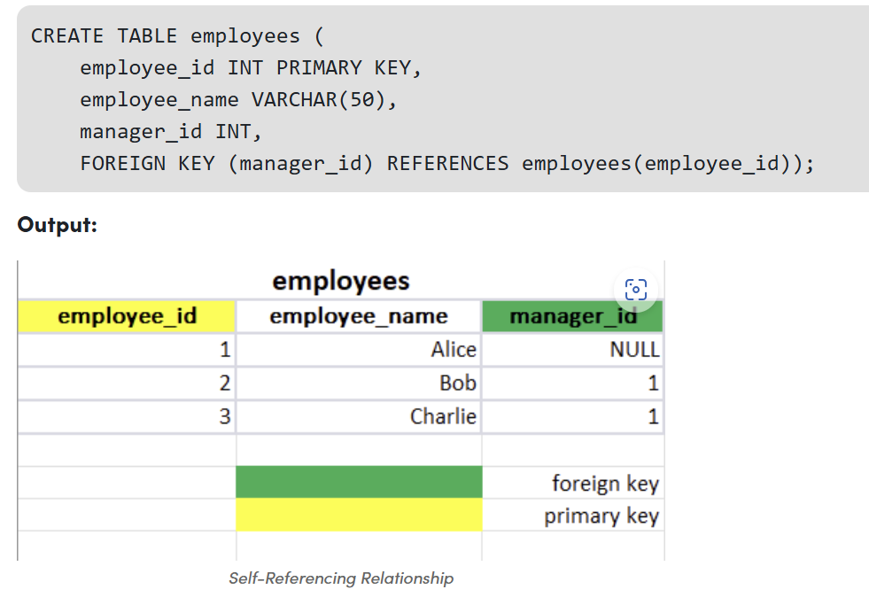

# **Normal Forms in DBMS**

Benefits of using Normal Forms

* Reduce duplicate data and wasted storage.
* Prevent insert, update, and delete anomalies.
* Improve data consistency and integrity.
* Make the schema easier to maintain and evolve

1. **First Normal Form (1NF):** Eliminating Duplicate Records

A table is in [1NF](https://www.geeksforgeeks.org/dbms/first-normal-form-1nf/)if it satisfies the following conditions:

* All columns contain atomic values (i.e., indivisible values).
* Each row & column has unique value
* The order in which data is stored does not matter.

Example of 1NF Violation: If a table has a column "Phone Numbers" that stores multiple phone numbers in a single cell, it violates 1NF. To bring it into 1NF, you need to separate phone numbers into individual rows.

2. **Second Normal Form (2NF):** Eliminating Partial Dependency

A relation is in [2NF](https://www.geeksforgeeks.org/dbms/second-normal-form-2nf/)if it satisfies the conditions of 1NF and additionally. No partial dependency exists, meaning every non-prime attribute (non-key attribute) must depend on the entire primary key, not just a part of it.

Example: For a composite key (StudentID, CourseID), if the "StudentName" depends only on "StudentID" and not on the entire key, it violates 2NF. To normalize, move StudentName into a separate table where it depends only on "StudentID".

3. **Third Normal Form (3NF):** Eliminating Transitive Dependency

A relation is in [3NF](https://www.geeksforgeeks.org/dbms/third-normal-form-3nf/)if it satisfies 2NF and additionally, there are no [transitive dependencies](https://www.geeksforgeeks.org/dbms/partial-full-and-transitive-dependencies/). In simpler terms, non-prime attributes should not depend on other non-prime attributes.

Example: Consider a table with (StudentID, CourseID, Instructor). If Instructor depends on "CourseID", and "CourseID" depends on "StudentID", then Instructor indirectly depends on "StudentID", which violates 3NF. To resolve this, place Instructor in a separate table linked by "CourseID".

4. **Boyce-Codd Normal Form (BCNF):** The Strongest Form of 3NF

[BCNF](https://www.geeksforgeeks.org/dbms/boyce-codd-normal-form-bcnf/)is a stricter version of 3NF where for every non-trivial functional dependency (X → Y), X must be a [superkey](https://www.geeksforgeeks.org/dbms/super-key-in-dbms/) (a unique identifier for a record in the table).

Example: If a table has a dependency (StudentID, CourseID) → Instructor, but neither "StudentID" nor "CourseID" is a superkey, then it violates BCNF. To bring it into BCNF, decompose the table so that each determinant is a candidate key.

5. **Fourth Normal Form (4NF):** Removing Multi-Valued Dependencies

A table is in [4NF](https://www.geeksforgeeks.org/dbms/introduction-of-4th-and-5th-normal-form-in-dbms/)if it is in BCNF and has no multi-valued dependencies. A multi-valued dependency occurs when one attribute determines another, and both attributes are independent of all other attributes in the table.

Example: Consider a table where (StudentID, Language, Hobby) are attributes. If a student can have multiple hobbies and languages, a multi-valued dependency exists. To resolve this, split the table into separate tables for Languages and Hobbies.

6**. Fifth Normal Form (5NF):** Eliminating Join Dependency

[5NF](https://www.geeksforgeeks.org/dbms/what-is-fifth-normal-form-5nf-in-dbms/)is achieved when a table is in 4NF and all join dependencies are removed. This form ensures that every table is fully decomposed into smaller tables that are logically connected without losing information.

Example: If a table contains (StudentID, Course, Instructor) and there is a dependency where all combinations of these columns are needed for a specific relationship, you would split them into smaller tables to remove redundancy.

# **Phenomena Defining Transaction Isolation Levels**

1. Dirty Read - a transaction reads data that has not yet been committed
2. Non Repeatable read - transaction reads the same row twice and gets a different value each time
3. Phantom Read - two same queries are executed, but the rows retrieved by the two, are different.

**The four standard isolation levels are:**

1. Read Uncommitted

lowest level of isolation where a transaction can see uncommitted changes made by other transactions. This can result in dirty reads, non-repeatable reads, and phantom reads.

1. Read Committed

In this isolation level, a transaction can only see changes made by other committed transactions. This eliminates dirty reads but can still result in non-repeatable reads and phantom reads.

1. Repeatable Read

This isolation level guarantees that a transaction will see the same data throughout its duration, even if other transactions commit changes to the data. However, phantom reads are still possible.

1. Serializable

This is the highest isolation level where a transaction is executed as if it were the only transaction in the system. All transactions must be executed sequentially, which ensures that there are no dirty reads, non-repeatable reads, or phantom reads

# **Windows function**

Differences Between RANK() and DENSE_RANK()

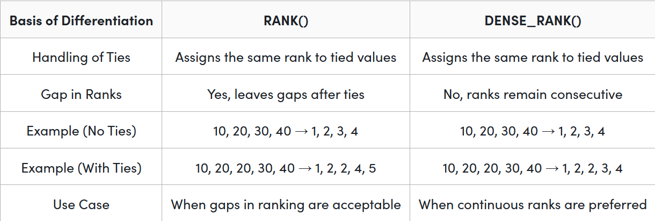

# **Quick Notes**

1. **When to use subquery?**

Use a subquery only when you need a value or set that cannot be computed directly in the current GROUP BY / JOIN context; otherwise, aggregate in the main query.”

* If you’re just counting, summing, or averaging over rows you already have → no subquery.
* If you need a single value per row from another table, or a filtered set, or a pre-aggregated result → subquery is okay.

1. **When to use count(*), count(column_name), SUM()?**

COUNT(*) → all rows, regardless of NULL values

COUNT(col) → non-null rows in that column

SUM() → Adds up the values of a column. Only works on numeric columns.

1. **BETWEEN, IN and EXISTS**

BETWEEN - Value in a range(inclusive), returns TRUE/FALSE per row

IN - Value matches any in a list/subquery, returns TRUE/FALSE per row

EXISTS - Subquery returns at least one row, returns TRUE/FALSE per row

1. **WHERE, GROUP BY, ORDER BY, HAVING**

WHERE- Filters individual rows, use Before GROUP BY

GROUP BY - Combines rows into groups, use when: You want to aggregate data with functions like COUNT(), SUM(), AVG()

HAVING - Filters aggregated groups, use After GROUP BY

ORDER BY - Sorts final result in ASC or DESC

1. **Where aggregated functions can be used? (COUNT(), SUM(), AVG(), MIN()< MAX())**

Valid – Select, Order by, Having

Invalid – Where, Group By

1. **LAG()**

LAG() lets you look at the value from a previous row in the result set.

Useful for calculating differences between rows

Syntax:

LAG(column, offset, default) OVER (ORDER BY some_column)

column → the column you want the previous value of

offset → how many rows back to look (default = 1)

default → value to return if there is no previous row (optional)

OVER (ORDER BY some_column) → defines the order of rows

Eg:

SELECT admission_date,

Count(admissions),

LAG(count(admissions)) OVER (ORDER BY admission_date) AS prev_day

FROM admissions_summary;